MINOR-2 PROJECT

Synopsis Report

Stock Price Prediction

Submitted By:

|  |  |  |
| --- | --- | --- |
| **Name** | **SAP ID** | **Specialization** |
| Jerem Lee | 500095190 | AIML (NH) |
| Nij Gadwal | 500094897 | AIML (NH) |
| Pasupuleti Jayasai | 500095655 | AIML (NH) |
| Garvit Sharda | 500093671 | AIML (H) |

Semester VI



Bachelor of Technology, School of Computer Science,

University of Petroleum & Energy Studies,

Bidholi Campus, Energy Acres,

Dehradun - 248 007, Uttarakhand.

Dr. Tarandeep Kaur Bhatia Dr. Anil Kumar **(Mentor Signature) (Cluster Head)**

**Table of Contents**

Title: - Stock price prediction 3

Abstract 3

Introduction 3

Literature Review 4

Problem Statement 4

Objectives 5

**METHODOLOGY…………………………………………………………………………………….…….5**

SWOT Analysis 7

Pert Chart 9

References 9

**Synopsis Report**

# Title: - Stock price prediction

# Abstract

T

his project aims to improve the accuracy of stock price forecasting in financial markets by using LSTM neural networks. Stock price forecasting is a key factor in investment decisions and economic planning, and traditional methods are effective to a certain extent. However, they often fail to capture the complexity of the stock market data because of their inability to deal with non-linear relations and long-run dependencies. On the other hand, the advantages of LSTM network are that they can model sequential data and capture temporal patterns. This project aims to advance the development of predictive analytics for finance by utilizing LSTM based models. The study reviews the existing literature on the prediction methodologies for stock prices, with a special emphasis on the LSTM network and its applications. Building on previous research, this project develops and analyzes LSTM based stock price forecasting models using historical stock market information. The goal of the findings is to improve the decision-making process and improve the understanding of the stock market dynamics.

# Introduction

In the world of financial markets, your research goal—using Long Short-Term Memory (LSTM) neural networks to precisely estimate stock values—is highly relevant. With their capacity to identify sequential patterns and long-term dependencies in time series data, LSTM networks present a promising route for enhancing predictive analytics in the financial sector.   
  
We hope to improve stock price forecast accuracy by using LSTM-based forecasting models, which will give investors and financial institutions useful information. This may help investors manage risks more skill fully and make better-informed decisions.

Leveraging cutting-edge deep learning techniques like LSTM networks can help overcome some of the issues with traditional forecasting approaches given the inherent volatility and complexity of financial markets. But it's important to recognize that there are still a lot of variables affecting market dynamics, making it difficult to predict stock prices with complete accuracy.   
  
Further improving the robustness and accuracy of your prediction models could involve investigating methods for reducing overfitting and integrating outside variables (such macroeconomic indicators, news sentiment, and market sentiment) into your models.

# Literature Review

S

tarting with seminal publications that introduced LSTM for time series forecasting is a good place to start when performing a literature review for stock price prediction using LSTM (Long Short-Term Memory) models. From there, you can examine more recent research for developments and applications relevant to stock market prediction. Among the important papers to mention are:

1. Hochreiter and Schmidhuber's "Long Short-Term Memory" (1997) - This is the first study that introduces LSTM networks and establishes the framework for using them in sequence prediction tasks.

2. Goyal et al. (2017) "Stock price prediction using LSTM, RNN, and CNN-sliding window model" This research investigates the use of LSTM and other neural network designs for sliding window-based stock price prediction.

3. Fischer and Krauss (2018) present "A deep learning framework for financial time series using stacked autoencoders and long-short term memory" - This paper improves the feature extraction and prediction of financial time series data by combining LSTM networks with stacked autoencoders.  
  
4. "Enhancing stock price prediction with LSTM recurrent neural networks using diverse technical indicators" written by Lin et al. (2018) In order to improve stock price forecast accuracy, this research explores the integration of various technical indicators with long short-term memory (LSTM) models.  
  
5. Vellido et al. (2020) published "Financial Time Series Forecasting with Deep Learning: A Systematic Literature Review: 2005-2019" - This paper offers a thorough overview of deep learning methods used in financial time series forecasting, including LSTM models, even if it is not specifically focused on LSTM.

# Problem Statement

P

rediction of the stock price is one of the most difficult tasks in the financial markets. The stock market data is highly dynamic and non-linear, making it difficult for traditional forecasting methods to accurately predict the movements of the stock price. The non-linearity of the stock market data and the long-term dependency on the stock price make it difficult for financial institutions to predict the stock price accurately. This is a major concern for investors and institutions looking to use predictive models to make informed investment decisions and reduce risks.

# Objectives

The goal of the project is to create and validate LSTM neural network models for the prediction of stock prices. The specific objectives of the project are as follows:

* Examine extensive literature on LSTM network methodologies for stock price prediction, with a particular emphasis on the use of LSTM networks in finance.
* Design and deploy LSTM based stock price forecasting models, taking advantage of the network’s ability to capture temporal relationships and non-linear trends.
* Analyze the performance of the model using appropriate metrics (MAE, RMSE).
* Compare LSTM models to traditional forecasting methods (autoregressive models, moving averages, etc.).

**Methodology:**

The following tasks are necessary to create an LSTM stock price prediction project:   
  
**1) Data collection:**

Get historical stock price information from dependable financial data providers like Kaggle, Yahoo Finance, and Alpha Vantage.   
  
**2) Data preprocessing:**

1. Take care of any outliers, missing numbers, and inconsistencies to make the data clean.
2. To help the model converge, normalize the data so that the various features are on the same scale.
3. Divide the information into test, validation, and training sets. Use 70–80% for training, 10-15% for validation, and the remaining portion for testing.

**3) Feature engineering:**

1. Choose pertinent characteristics, such as trade volume, open, high, low, and close prices.
2. Adding elements like relative strength index (RSI), moving averages, or other technical indicators is an optional addition that could aid in identifying underlying trends in the data.

**4) Sequence Generation:**

* For the LSTM model, generate input sequences and matching output targets.
* Select the prediction horizon (e.g., closing price of the next day) and the sequence length (e.g., number of prior time steps) for the input data.

**5) Model Construction:**

1. Using a deep learning framework like TensorFlow or PyTorch, design the LSTM architecture.
2. To maximize model performance, play about with the number of LSTM layers, units, activation functions, and dropout rates.
3. Assemble the model by designating the optimizer (such as Adam or RMSprop) and the loss function (such as mean squared error).

**6) Model Training:**

* Make use of the training data to educate the LSTM model.
* To avoid overfitting, keep an eye on the model's performance on the validation set.
* To enable the model to identify patterns in the data, go over the data several times (epochs).

**7) Prediction:**

* To make predictions on fresh, untainted data, apply the trained LSTM model.
* To evaluate the model's performance, track its forecasts over time and contrast them with real stock prices.

**8) Fine-tuning and Optimization**:

To increase forecast accuracy, experiment with various hyperparameters and model setups.   
To catch more subtle trends in the data, think about adding new features or improving current ones.

**9) Deployment and Monitoring:**

Use the trained model to make predictions in batches or in real time. To guarantee the model's efficacy throughout time, keep an eye on how it performs in production and retrain it on occasion with new data.

**Flowchart :**

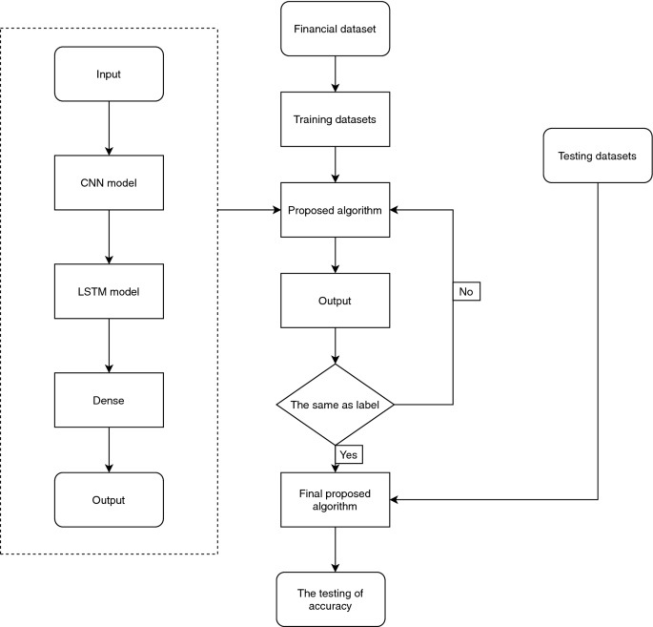

# *Fig 1. Stock Price Prediction*

# 

# SWOT Analysis

**Strengths:**

* **Data Availability:** A significant amount of historical stock price data is available and can be used for forecasting and research.
* **Advanced Algorithms:** Large datasets may be analyzed through the use of complex algorithms for stock price prediction, thanks to developments in machine learning and artificial intelligence.
* **Technological** **Tools:** Effective analysis and modelling of stock price data is made possible by the availability of strong computational tools and software platforms.
* **Market Insights:** Stock price prediction models can offer insightful information about current market conditions, assisting investors in making wise choices.

**Weaknesses:**

* **Market Volatility:** It can be difficult to predict stock prices with precision because of the multitude of factors that impact stock markets, such as geopolitical events, investor emotions, and economic data.
* **Model Complexity:** Creating precise stock price prediction models frequently necessitates the use of sophisticated algorithms and substantial computing power, which may not always provide trustworthy outcomes.
* **Overfitting:** The model may be overfit to past data, which could result in poor generalization and erroneous predictions in practical situations.
* **Black Swan occurrences:** Unexpected or "black swan" occurrences have the potential to have a major impact on market prices, making typical prediction models useless.

**Opportunities:**

* **Big Data Analytics:** New patterns can be found and existing stock price prediction models can be improved upon thanks to the growing availability of big data and sophisticated analytics techniques.
* **Alternative Data Sources:** The accuracy of stock price forecasts can be improved by including data from alternative sources like web traffic, satellite imaging, and social media sentiment.
* **Real-Time Prediction:** Technological developments allow market data to be processed in real-time, which facilitates prompt stock price forecasts and proactive decision-making.
* **Interdisciplinary Research:** New methods for predicting stock prices can be developed by cooperation between data scientists, domain experts, and finance professionals.

**Threats:**

* **Regulatory Risks:** The legitimacy and legality of stock price prediction models may be affected by regulatory modifications or actions in the financial markets.
* **Competition:** Price pressure and commoditization may result from increased competition brought on by the growth of stock price prediction tools and services.
* **Data security and privacy:** Security issues are brought up by the use of private financial data to forecast stock prices.
* **Interpretability of the Model:** Investors may find it challenging to comprehend the underlying causes influencing the predictions in complex prediction models due to their lack of interpretability.
* **Ethical Concerns:** Stock price prediction techniques are seriously threatened by ethical concerns about the application of predictive analytics in financial markets, particularly those pertaining to fairness, transparency, and prejudice.

# Pert Chart

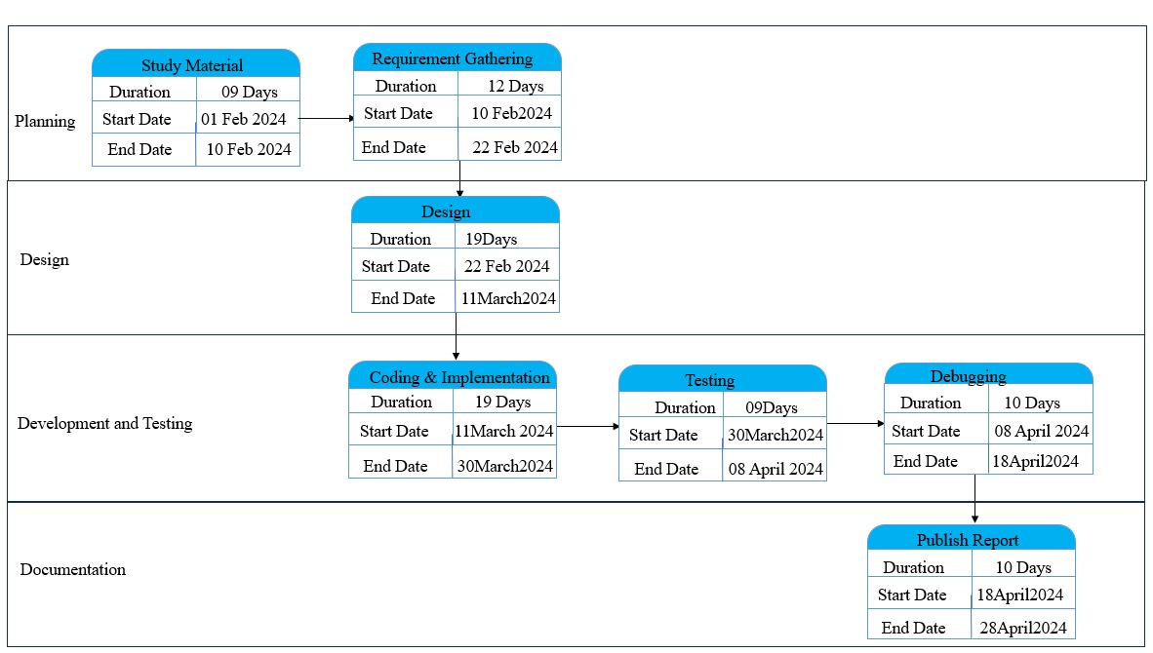

*Fig.2: Stock Price prediction*

# References

**Research Papers :**

1. Addison, P. S. (2002). The illustrated wavelet transform handbook. Napier University.

Avramov, D. (2002). Stock returns predictability and model uncertainty. Journal of

Financial Economics, 64, 423–458.

1. Brock, W., Lakonishok, J., & LeBaron, B. (1992). Simple technical trading rules and

the stochastic properties of stock returns. The Journal of Finance, 47, 1731–1764.

1. Campbell, J. Y., & Thompson, S. B. (2008). Predicting excess stock returns out of

sample: Can anything beat the historical average? Review of Financial Studies,

21,1509–1531.

**Related Articles :**

1. Campbell, J. Y., & Vuolteenaho, T. (2004). Bad beta, good beta. The American

Economic Review, 94, 1249–1275.

1. Chen, J., Jiang, F., & Tong, G. (2017). Economic policy uncertainty in China and

stock market expected returns. Accounting and Finance, 57, 1265–1286.

1. Clark, T. E., & West, K. D. (2007). Approximately normal tests for equal predictive

accuracy in nested models. Journal of Econometrics, 138, 291–311.